Task 1 – TryHackMe Walkthroughs
Name: V Haritha
TryHackMe Profile: https://tryhackme.com/p/hariiithaa
Room 1: What's Networking?
What I Did
I started the room by learning the basic idea of a network. The room compared networks to things like friend groups and transport systems which made the concept pretty easy to understand. I then learned how computers, phones and other devices communicate through networks.
I saw the difference between public and private IPs. I also went through IPv4 and IPv6. Why IPv6 was introduced because IPv4 has a limited number of addresses.
Next I read about MAC addresses. How they identify a devices network interface. The practical section showed how MAC spoofing can make a device appear as another device on a network. I then used `ping` to test connectivity and completed the questions in the room.
What I Learned
This room gave me my first proper understanding of networking. I learned that devices need ways to identify each other through IP and MAC addresses. I also understood the difference between private IP addresses and got a basic idea of why IPv6 is important.
The MAC spoofing practical was especially interesting because it showed me that MAC addresses can be faked and shouldn't automatically be treated as proof that a device's trustworthy. Using `ping` also helped me connect the theory to a networking tool.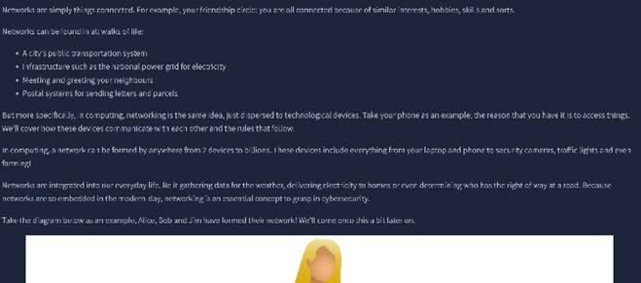 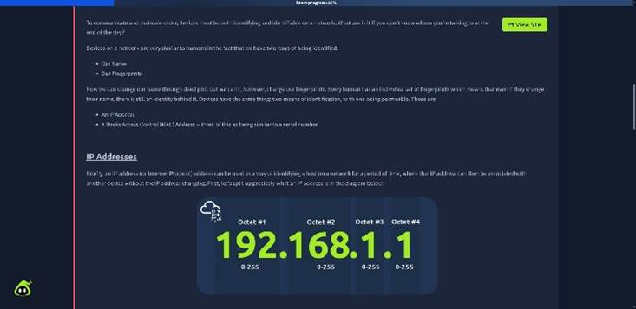 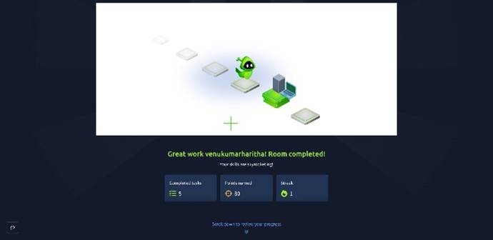
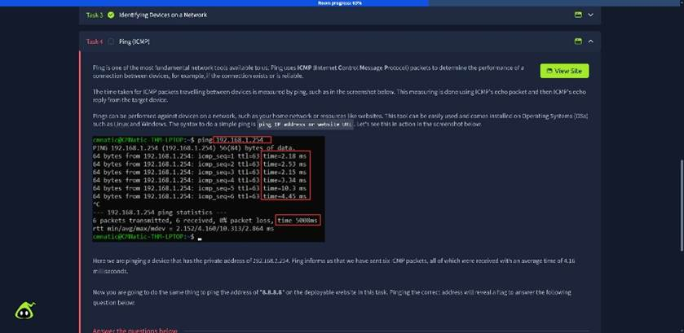
---
Room 2: Intro to Networking
What I Did
This room went deeper into networking starting with the OSI model. I went through its seven layers. Learned what each layer is responsible for. I then learned about encapsulation where extra information's added to data as it moves through the layers before being sent across a network.
After that I learned about the *TCP/IP model and how it relates to the OSI model. I also learned how TCP establishes a connection using the three-way handshake: SYN, SYN-ACK and ACK.
The practical part introduced me to tools such as `ping` `traceroute` `whois` and `dig`. I used these to understand connectivity the route taken by network traffic, domain information and DNS lookups.
What I Learned
This room helped me understand what actually happens when data travels across a network. The OSI model made it easier to break networking into parts instead of seeing it as one complicated process.
I also learned that tools, like `ping` and `traceroute` aren't random commands. They can actually help troubleshoot networks. Learning about DNS and `dig` also helped me understand how a domain name gets connected to an IP address.
Overall these two rooms gave me a networking foundation that I can build on for cybersecurity.
